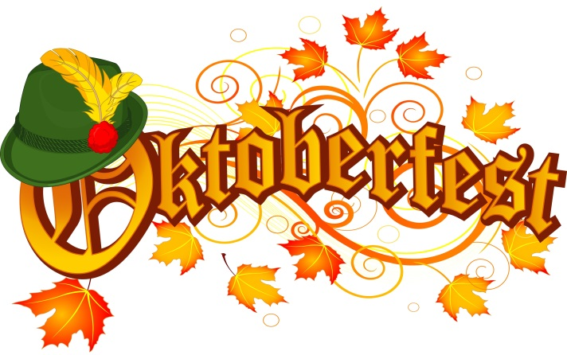
CANCELLED FOR 2015
The Dunsmuir Botanical Gardens will not host
Oktoberfest this year but hopes to be back next
year, depending on the availability of space and
sausages! We thank the public for your support this
past year in other ways. Please come see our photo
contest during Artwalk at the Siskiyou Arts Museum.

